DETAILS OF PROSPECTIVE EMPLOYEE
NAME: 26439 OKPOJU, FRANKLIN ONYILO Relationship: A worker in the Youth section of the church under my leadership.
Do you agree to be his/her referee? Yes .
1-5 Years
6 - 10 Years
Over 10 Years
Less than 1Year
How long have you known him/her?

Please tick as appropriate your opinion on the following attributes of the employee:

Unsatisfactory
Satisfactory
Good
Excellent
HONESTY/TRUST/MORALITY

ATTITUDE
CONDUCT
SELF DISCIPLINE/DEDICATION

RELIABILITY/RESPONSIBILITY
INTEGRITY

Would you recommend him/her for the job in CBN? Yes
Please comment freely on the candidate: He is diligent ,dedicated, dependable and trustworthy.

REFEREE PERSONAL DETAILS
Full Name: Pastor Solomon B. Eniolorunda.
Nationality: Nigerian Marital Status :Married
Home Address:
No 2 Potters House,Church Road, New Karu, Nasarawa State.
Office Address:
Deeper Life Street, Deeper Life Junction, Koroduma, One man village, Nasarawa State.

Occupation: Clergy Mobile No(s):_08158594424 /08169960146

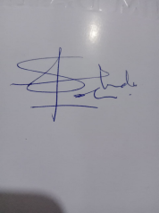
- Mail: pastorsolomon31@gmail.com
Signature: Date: 24th January 2022

